- A) User benefits:
  - The desktop application is a full Enterprise Resource Planning suit that encompasses all departments and conceivable aspect of the company, from scheduling meetings, to updating the company’s website, client relations, to payroll and everything in between. It also has a full custom IDE packed with the companies API’s for rapid development harnessing the power of code reusability.
  - The mobile application is equipped with efficient and productive “on-the-go” tools to facilitate the employees out in the field. For instance, it can perform real time Mockup’s for potential websites and applications, which in turn, can be promptly displayed for clients, leveraging the law of faster returns – concept depicted by Ray Kurzweil – and consequentially increasing sales margin.
- B) Initial Usability Design Goals and Rationale
  - The current usability goal of focus for the desktop is a tool to facilitate browsing and promptly make a file available for editing. That is, the tool being developed, can instantly display all files for all projects in a tree fashion, facilitating the browsing experience for the software engineer. While in the same window, the engineer can edit files as needed.

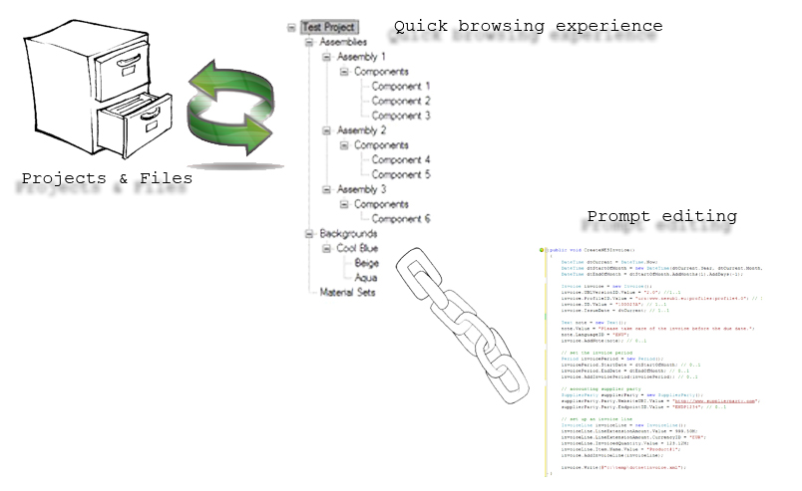

- D) Focus on three different tasks (per members) the system provides for the user -- and gives the Sequence Model & artifact Model for those tasks.
  - The user can readily access files pertinent to each project
  - The files can be edited on-the-fly.
  - The files can be shared.

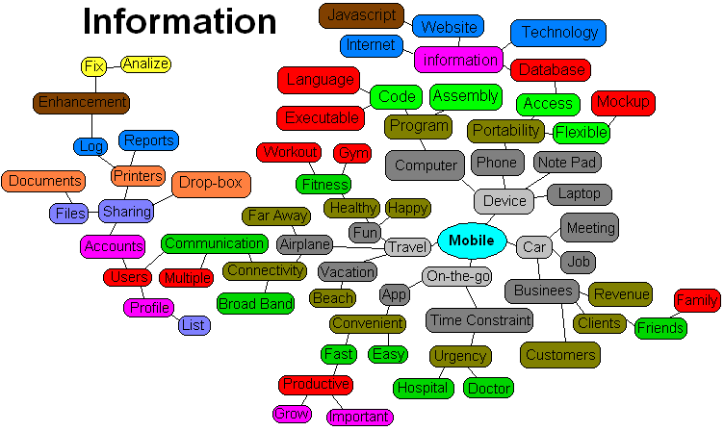
Tasks
- Travel arrangement  - Meeting arrangement  - Fast interactivity  - Easy to learn  - Various list displays  - Profile  - Users  - Account management | - Sharing  - Documents  - Files  - Print  - Report  - Log  - Communicate important events  - Connect on the go  - Productive tools | - Business enhancer  - Customer satisfaction  - Phone portability  - Auto bug report  - Log of every task accomplished  - Client Mock-up view  - Wifi enabled  - Hot spot device  - Schedule keeper

- F) Illustrations of the structure of the task (organization of the nodes) HTA
  - The projects and files are stored on disk.
  - The application sifts through the projects folder.
  - Gathers all the projects and its respective files.
  - Organizes them in a treeview.
  - As a file is selected, it is promptly displayed for editing.
  - File can be saved accordingly.

- G) Initial Conceptual Design (Prototype)
